Kendall Joyner

5/5/2024

CTEC 298

learnPython Part 3

Numpy Arrays

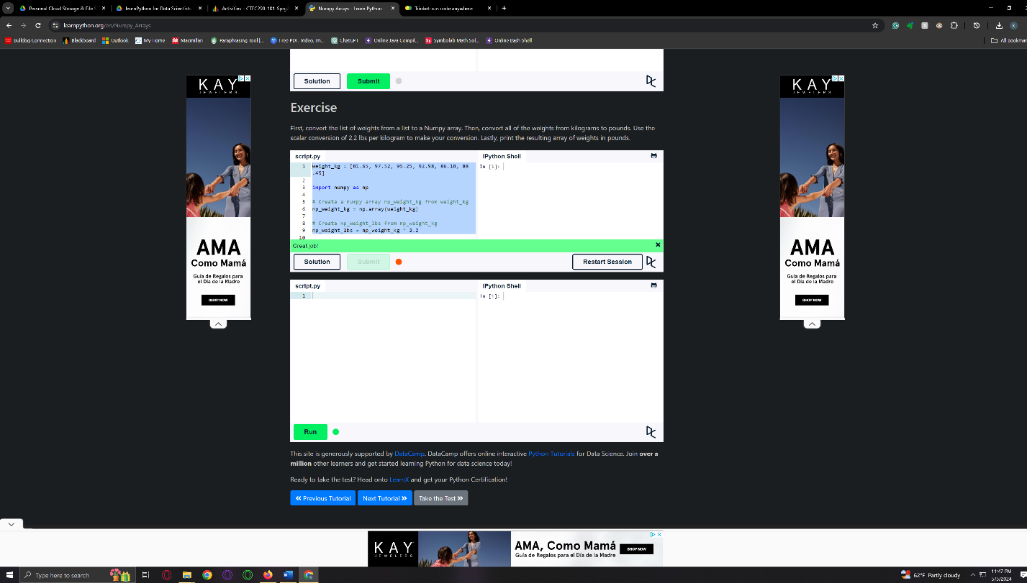

Pandas Basics

